嘉義縣108年新港溪北六興宮正黑面三媽盃小六學藝競試 英語科試卷
本測驗提共40題，包括第一大題的聽力理解15題（題號1-15）及第二大題的閱讀理解25題（題號16-40）。每題2.5分。
第一大題: 聽力理解

Part A: 依據圖片選擇最適當的答案 (1-5各題撥放二次)
1 | (A) |  | (B) |  | (C) |  |  | (D)
 | 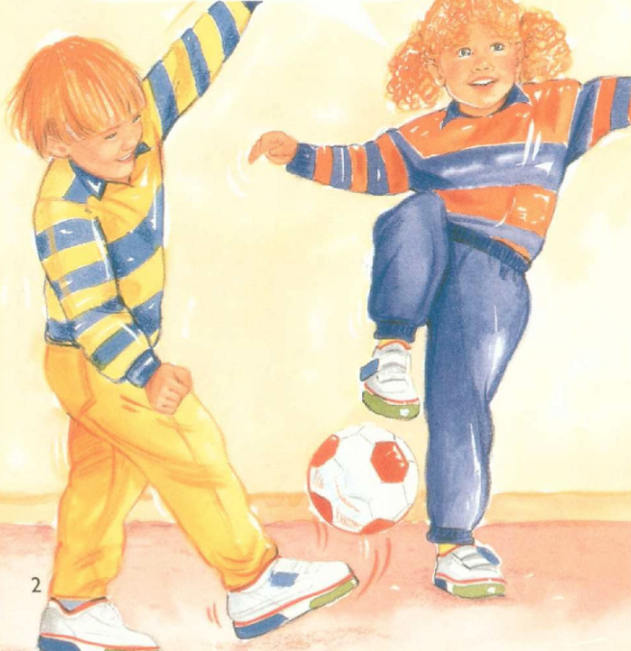 |  | 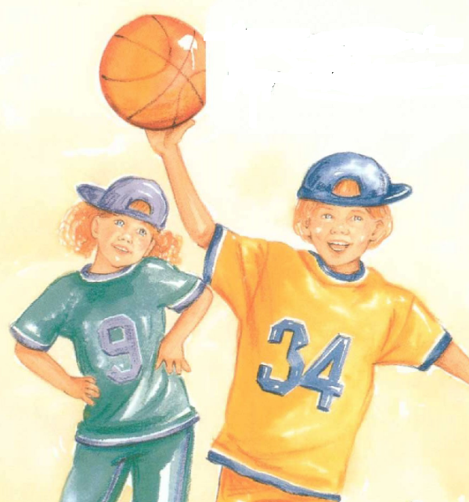 |  | 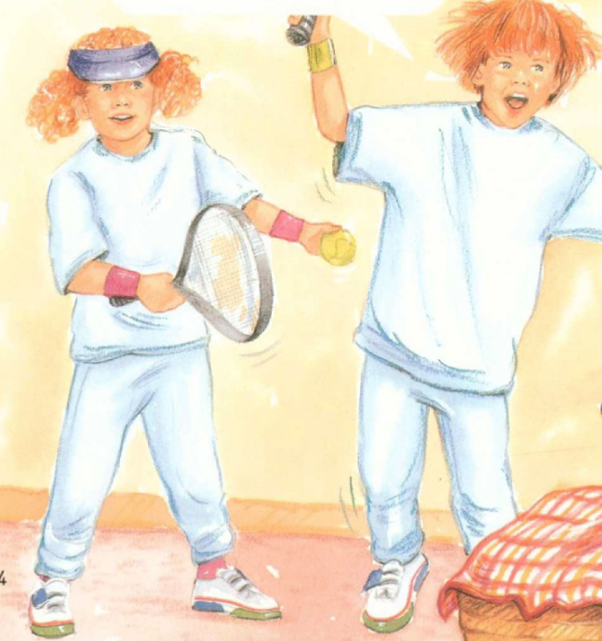 |  |  | 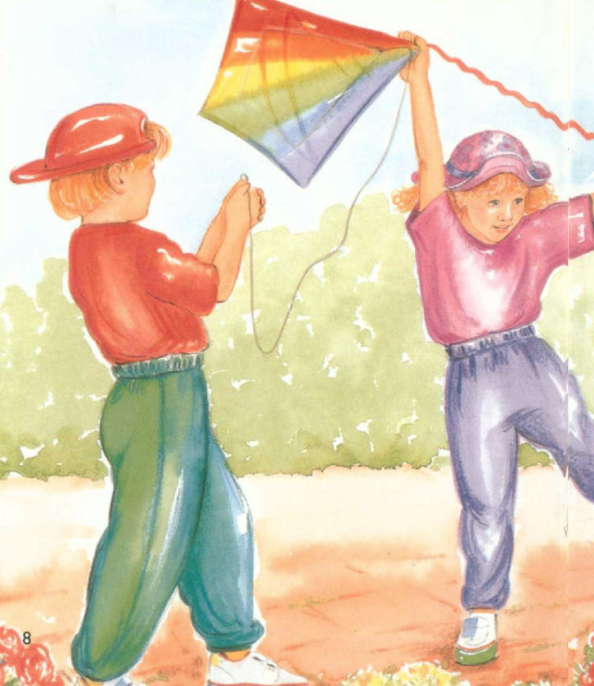
2 | (A) |  | (B) |  | (C) |  |  | (D)
 | 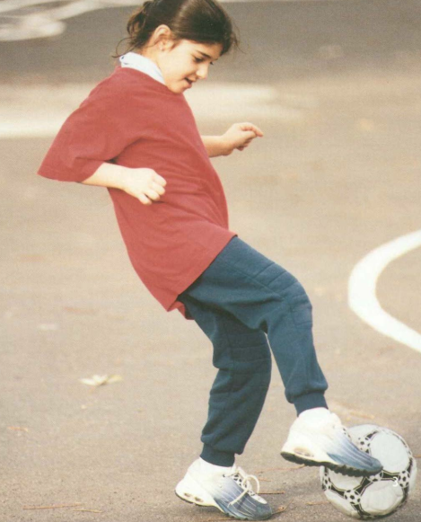 |  | 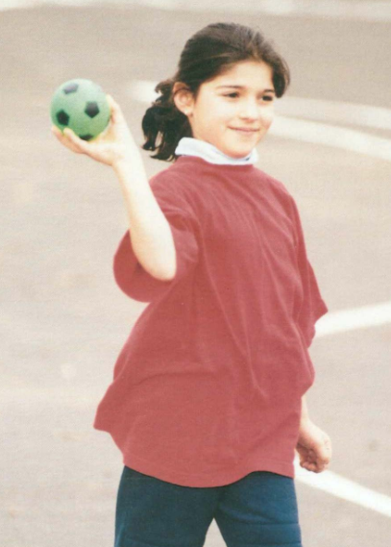 |  | 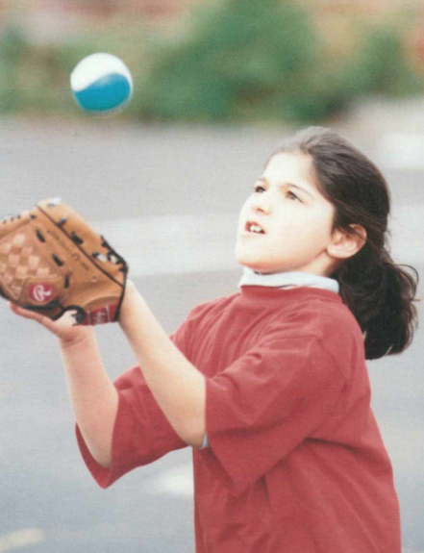 |  |  | 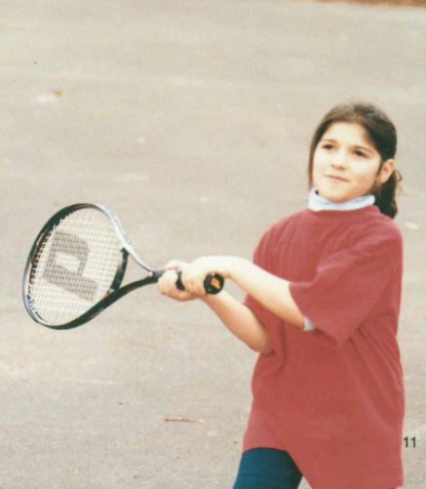
3 | (A) | (B) |  | (C) |  |  | (D)
 | 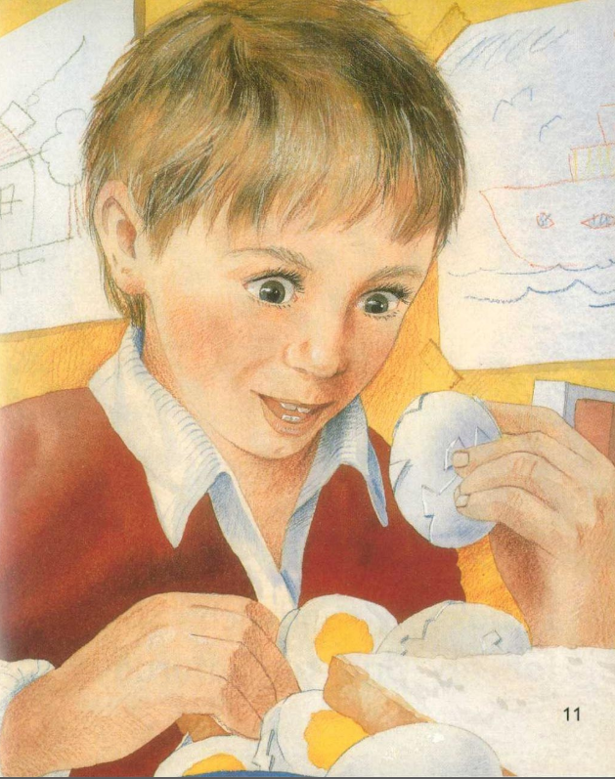 |  | 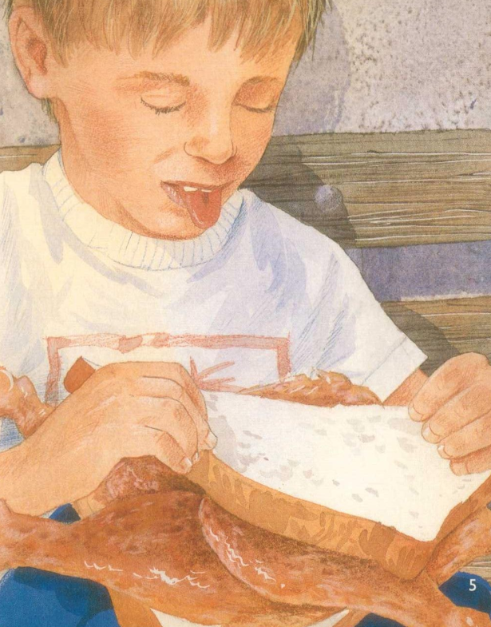 |  | 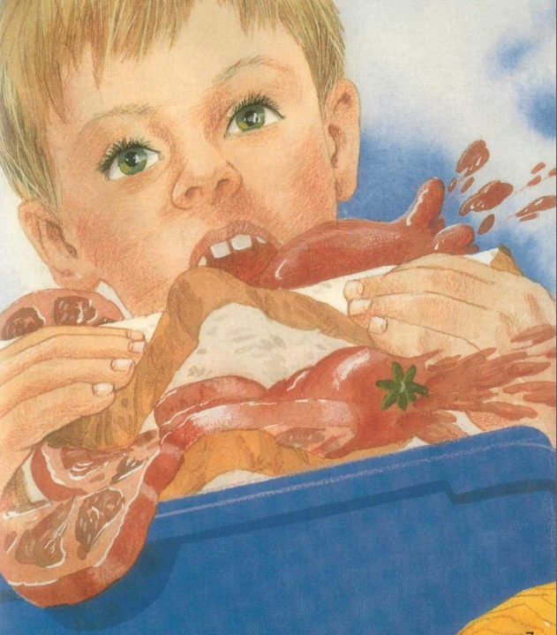 |  |  | 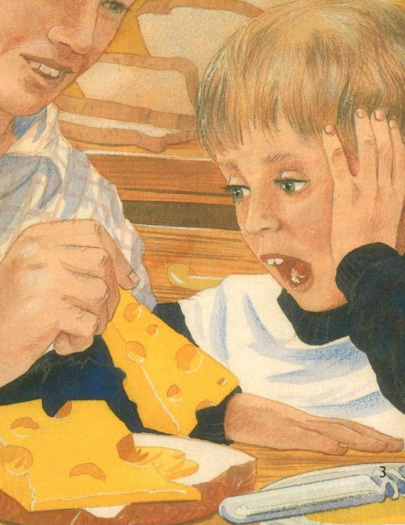
4 | (A) |  | (B) |  | (C) |  |  | (D)
 | 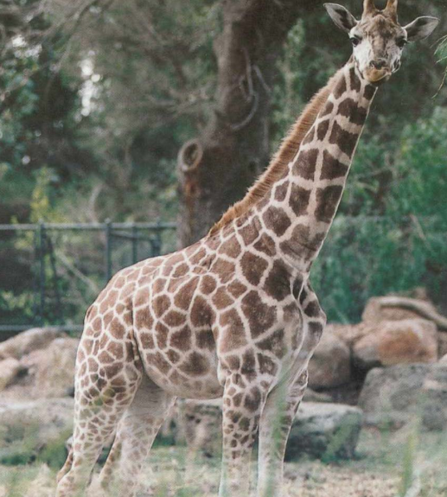 |  | 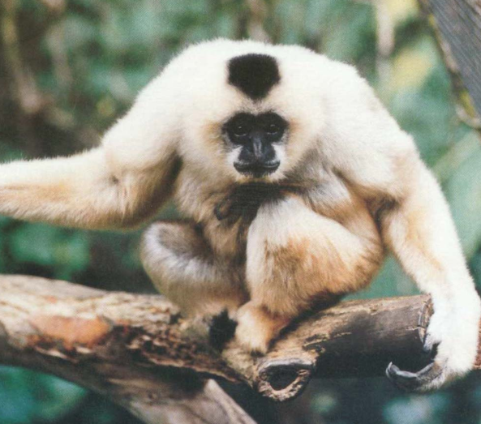 |  | 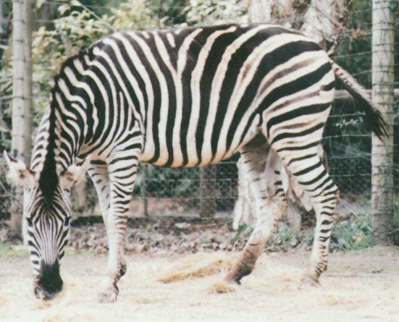 |  |  | 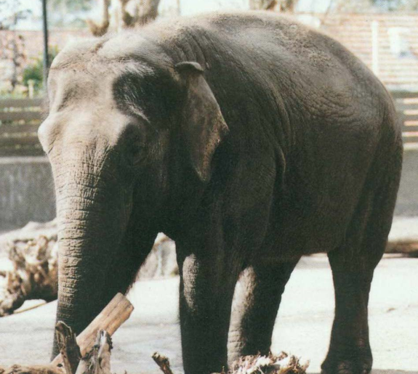
5 | (A) |  | (B) |  | (C) |  |  | (D)
 | 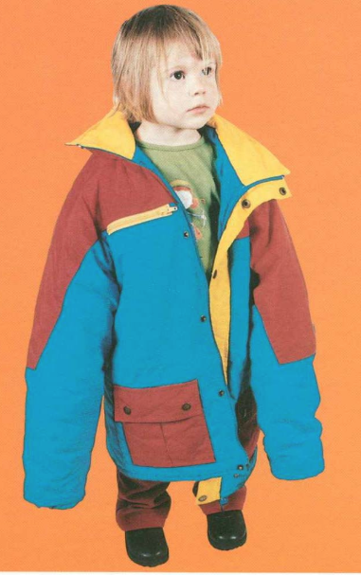 |  | 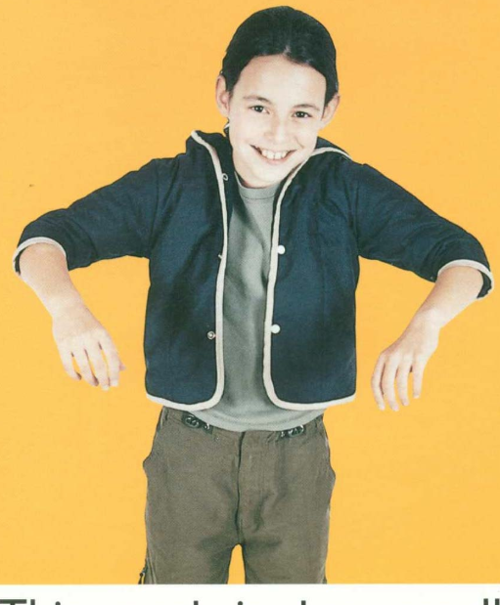 |  | 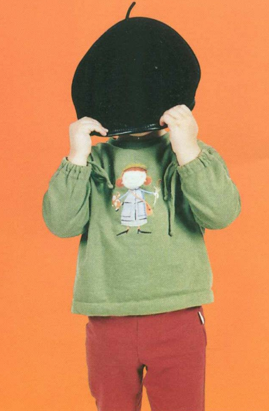 |  |  | 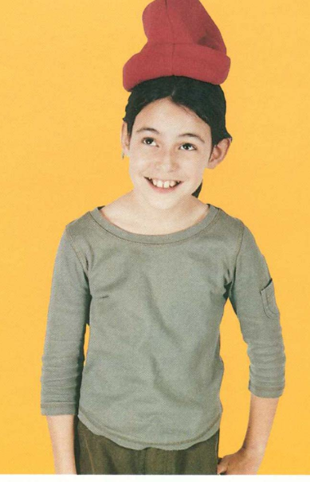

Part B: 聽CD，並根據你聽到的各段的內容及問題，選擇最適當的答案，把答案(A,B,C或D)寫在題號前的空格中（6-15各題撥放一次）。
____ | 6 | Where are they?
 | (A) | In a school | (B) | In a gym
 | (C) | On a plane | (D) | In a supermarket
____ | 7 | What are they doing?
 | (A) | Buying clothes | (B) | Chatting about an exam
 | (C) | Waiting for the class to start | (D) | Having a meal
____ | 8 | What’s the relationship between the two girls?
 | (A) | Teacher and student | (B) | Good friends
 | (C) | Saleswoman and customer | (D) | Brother and sister
____ | 9 | What does Anna’s brother look like?
 | (A) | He’s short and fat. | (B) | He wears glasses.
 | (C) | He wears a white shirt. | (D) | He’s tall and thin.
____ | 10 | What does Susan want to do?
 | (A) | She wants to know Alex. | (B) | She wants to invite Anna to a movie.
 | (C) | She wants to buy lunch for Alex. | (D) | She wants to have lunch with Anna tomorrow.

____ | 11 | How can a child save water?
 | (A) | Plant trees in the garden. | (B) | Take quick showers.
 | (C) | Take bottles to the recycling bin. | (D) | Walk short distances.
____ | 12 | What is the passage about?
 | (A) | Children are too little to help the Earth. | (B) | Walking is a good exercise.
 | (C) | Children can do many things to help the Earth. | (D) | How to plant trees in the garden.
____ | 13 | What is a bad thing that Sooty sometimes does?
 | (A) | Hiding in a paper bag | (B) | Drinking a lot of water
 | (C) | Ringing the bell | (D) | Chasing birds in the backyard
____ | 14 | What game does Sooty like to play?
 | (A) | Licking her fur | (B) | Ringing the bell
 | (C) | Looking at the street | (D) | Hiding in a paper bag
____ | 15 | Why does Sooty sit near the window and look at the street every afternoon?
 | (A) | She is waiting for her friend, the writer. | (B) | She likes to watch people and cars on the street.
 | (C) | She’s waiting for another cat to appear. | (D) | She loses her bell and is locked outside.

(下一頁有題目，請繼續作答)

第二大題：閱讀理解
Part A: 依據圖片及問題選擇最適當的答案
Look at the picture and choose the best answer.
16 | What happens?  - The baby is crying.  - Toys are everywhere.  - The baby’s sister is picking up toys.  - The baby is drinking. | 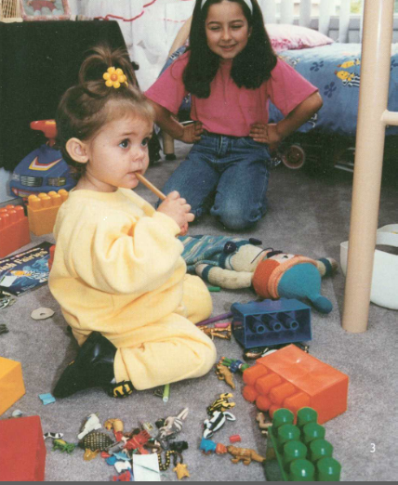
17 | What’s in the picture?  - A butterfly is resting on the flowers with its wings up.  - A butterfly is flying around the flowers.  - A butterfly is sleeping on the flowers with its wings down.  - A butterfly is lying on the flowers. | 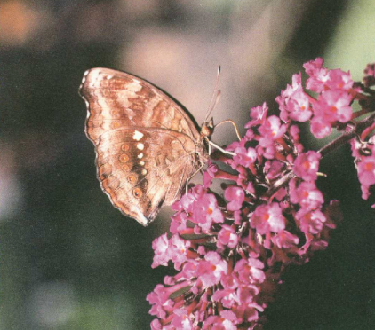
18 | What color are the tomatoes?  - The red ones are larger.  - They’re green and red.  - There’re lots of tomatoes.  - The girl likes the tomatoes. | 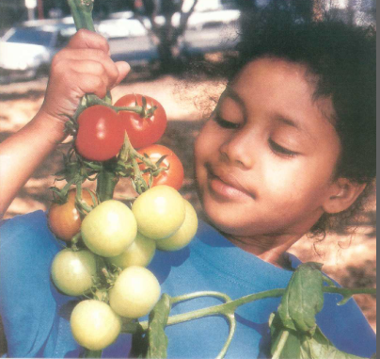
19 | What are they doing?  - They’re fishing.  - They’re cooking a fish.  - They’re eating.  - They’re playing in the river. | 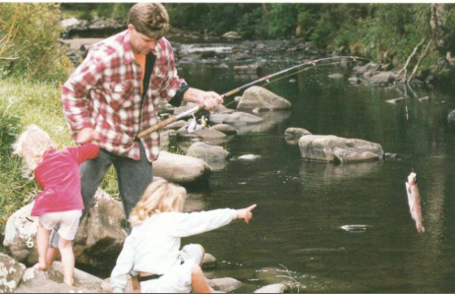
20 | What’s at the end of the street?  - A temple  - Two rows of buildings  - Many cars  - A row of cars and buildings | 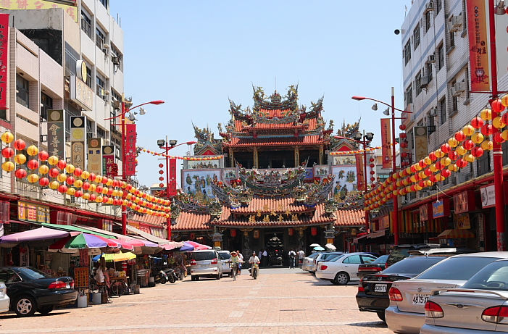
21  22  23 | What is the time for taking a walk?  - 7:00 AM  - 7:30 AM  - 3:30 PM  - 4:30 PM  What time will Father come home?  - 11:45 AM  - 12:30 PM  - 5:30 PM  - 6:00 PM  Who is Adam?  - His teacher  - His father  - His brother  - His Mommy | 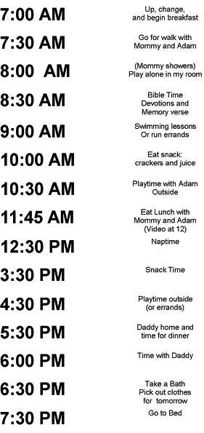
24  25 | What are they doing?  - Cleaning the room  - Drawing pictures  - Doing a puppet show  - Writing homework  What is the purpose of the light?  - So they can see their homework.  - To make their room look clean.  - To make their pictures look nice.  - To create shadows on the screen. | 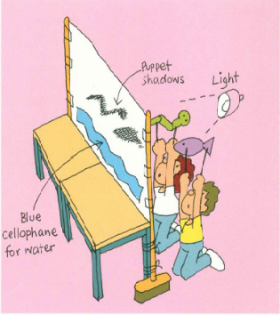

Part B: 短文閱讀
依據文章選擇最適當的答案Choose the best answer according to the passage.
Little Boy Blue,
Come blow your horn,
The sheep’s in the garden,
The cows in the corn.

But where is the boy
Who looks after the sheep?
He’s under a tree,
Fast asleep.

Will you wake him?
No, not I,
For if I do
He’s sure to cry!

____ | 26 | What’s the job of the boy?
 | (A) Growing the corn |  | (B) Taking care of the sheep
 | (C) Sleeping under a tree |  | (D) Waking up the boy
____ | 27 | Where is the boy?
 | (A) In the house |  | (B) Among the sheep
 | (C) In the corn |  | (D) Under a tree
On holidays last month, Jack’s family went to Shell Beach. They stayed in a holiday house. Jack learned to swim. Scott learned to surf. Now he can catch big waves and ride them all the ways to the beach. That’s great fun! Jack hopes to learn to surf next year.

____ | 28 | What can Jack do by next year?
 | (A) Stay in the holiday house |  | (B) Swim
 | (C) Swim and surf |  | (D) Surf
____ | 29 | Where did they spend their holidays?
 | (A) Last month |  | (B) Shell Beach
 | (C) Scott |  | (D) Jack’s family
Early one morning Anna got out of bed. She got dressed and put on her hat. Her father was waiting for her in the kitchen. “Sshh!”he said. “Don’t wake the others.” They went out the front door and into the street.
As they walked down the road, Anna and her father saw the town waking up. Someone was taking milk to the shop. Garbage trucks were collecting the trash. The street sweeper was cleaning the road. They saw a boy delivering papers and a woman walking her dog. They also saw a man going fishing and people jogging.
But Anna and her father had something else to do. They walked to the bakery. They bought some warm bread and some muffins. They bought two rolls. “One for you and one for me,” said her father. They ate the rolls as they walked home.
When they got home, everyone was still asleep. They set the table and put the bread and the muffins on the table. “Go and wake everyone up, Anna,” her father said. “Everybody! Breakfast is ready!” Anna called.
“That smells good,” her mother said. “What a wonderful breakfast!”
“Happy Birthday, Mom!” said Anna.
____ | 30 | Why did Father ask Anna to be quiet when they went out?
 | (A) It’s too early to wake others up. |  | (B) The town was still sleeping.
 | (C) They wanted to give a surprise to Mother on her birthday. |  | (D) The breakfast was not ready yet.
____ | 31 | What did Anna and her father do early that morning?
 | (A) Walking their dog |  | (B) Taking milk to the shop
 | (C) Going fishing |  | (D) Buying some bread
____ | 32 | Who ate the rolls?
 | (A) Father |  | (B) Father and Anna
 | (C) Anna |  | (D) Mother and Anna
In 1974, a very big storm struck the city Darwin, Australia on Christmas Eve. The name of the storm was Cyclone Tracy.
Almost all of the city was harmed by the cyclone. Houses were blown to bits and trees were torn out of the ground. Cars were turned over. Boats were blown onto the shore and planes were damaged. People had no houses to live in. There was no water or power. Many people went away to other places to live until the city was rebuilt.

____ | 33 | Which city was struck by the cyclone?
 | (A) Darwin |  | (B) Christmas
 | (C) Tracy |  | (D) Australia
____ | 34 | What is a cyclone?
 | (A) A very big monster from the sea |  | (B) Very big winds that can destroy houses, cars, and boats
 | (C) A serious power problem |  | (D) Very large trees that were torn out of the ground
____ | 35 | What happened to most people after the cyclone?
 | (A) They climbed up trees to stay safe. |  | (B) They hid in their cars or boats.
 | (C) They tried to survive in the city without water or power. |  | (D) They had to move to safe places.
My little black cat
Is not very fat.
When I pat her fur,
She gives a big purr.
Her whiskers are neat.
She has four white feet.
Her eyes are green.
Her ears are keen.
She eats meat and fish
From a yellow dish.
She sleeps many hours
Among the flowers.

____ | 36 | What color are the cat’s feet?
 | (A) Black |  | (B) Neat
 | (C) White |  | (D) Green
____ | 37 | Where does the cat like to rest?
 | (A) Meat and fish |  | (B) Many hours
 | (C) A yellow dish |  | (D) In the garden
Fast Food
Many children like ‘fast food’ such as chips and hot dogs more than healthy food like fruit and vegetables. Fast food is delicious! We like salty golden chips, meaty hot dogs, and the sweet strawberry milkshake. When we’re really busy, it’s quicker to go to a café or a fast food restaurant than it is to go home and cook a meal. It’s a lot less trouble and there isn’t any washing up!
Fast food is not rubbish. It does have some protein, fiber, vitamins and minerals. However, many types of fast food contain lots of salt, fat or sugar. Every day, we need to eat food from the five main food groups. To be healthy, we should have lots of cereals, fruit and vegetables. Growing children must have food from the milk group to build strong bones. If we eat too much fast food, our diets will not have enough vitamins and minerals. We won’t have enough energy to play and learn.
Fast food is appetizing, but it is best to keep it as a special treat. It’s not a good idea to have fast food every day.

____ | 38 | What is the writer’s idea about fast food?
 | (A) We can eat it every day. |  | (B) We can eat it sometimes.
 | (C) We should not eat it at all. |  | (D) It is good for children.
____ | 39 | What kind of food do children need to grow strong bones?
 | (A) Milk |  | (B) Cereals
 | (C) Fiber |  | (D) Fruit
____ | 40 | Which of the following has the most sugar?
 | (A) Hot dogs |  | (B) Milkshake
 | (C) Chips |  | (D) Vegetables

